**FINAL Exam: DATABASE**

**WEP 2024**

**{3h 00}**

25 JAN 2023

**RULES:**

* Chatting and talking to other students is forbidden
* You are allowed to use PhpMyAdmin or VSCode or any other software. But it is not required
* Write (copy/paste) your answer below the question. Do not screenshot.

**HOW DO I SUBMIT THE EXAM?**

* Save this document as a yourfullname.PDF file
* In Google Classroom, attach this file to submit.

|  |  |
| --- | --- |
| **EXERCISES** | **POINTS** |
| THOERYS | 20 |
| EXERCISE 1 | 20 |
| EXERCISE 2 | 20 |
| EXERCISE 3 | 20 |
| EXERCISE 4 | 20 |
| EXERCISE 5 | 20 |
| **TOTAL** | **100** |

# Exercise 03 (20 points) Basic SQL Query

Write SQL query to create tables that have in Entity Relational Diagram (ERD) below:

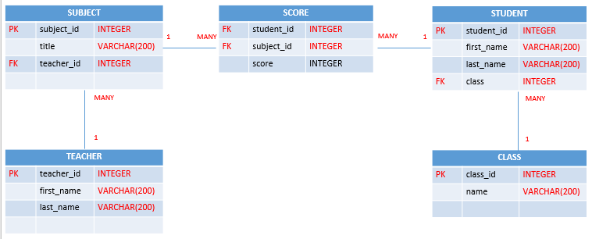

**Your Query:**

**Create table teachers**

create table teachers(

teacher_id int primary key,

first_name varchar(200),

last_name varchar(200)

);

**Create table classes**

create table classes(

class_id int primary key,

name varchar(200)

);

**Create table students**

create table students(

student_id int primary key,

first_name varchar(200),

last_name varchar(200),

class_id int,

foreign key (class_id) references classes(class_id)

);

**Create table subjects**

create table subjects(

subject_id int primary key,

title varchar(200),

teacher_id int,

foreign key(teacher_id) references teachers(teacher_id)

);

**Create table scores**

create table scores(

student_id int,

subject_id int,

score int,

foreign key(student_id) references students (student_id),

foreign key(subject_id) references subjects(subject_id)

);

# Exercise 04 (20 points) SQL Query Select

***Important****: Import database name “database_final_exam.sql” into your databasae.*

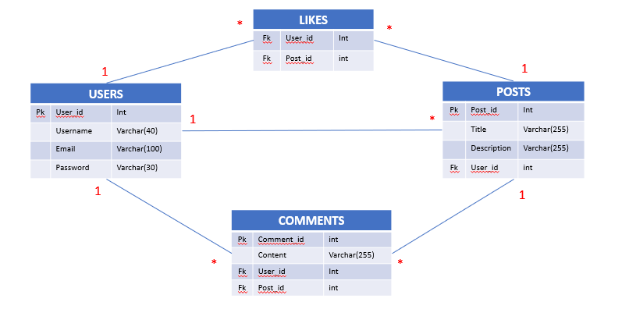

**Q1 – (10 POINTS):** Write a SQL statement to display all POSTS for the user named “**Rady Y**”

**Expected result:**

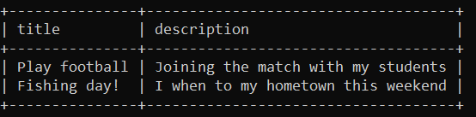

**Your Query:**

|  |
| --- |
| **select title, description from posts inner join users on posts.user_id=users.user_id where username='Rady Y';** |

**Q2 – (10 POINTS):** Write a SQL statement to display the username of who likes on many posts.

**Expected result:**

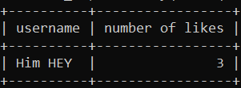

**Your Query:**

|  |
| --- |
| **select users.username, count(users.user_id) AS "number of likes" from likes inner join users on likes.user_id=users.user_id group by users.user_id order by count(users.user_id) desc limit 1;** |